

***Entity Framework***

**Lab Guides**

|  |  |
| --- | --- |
| Document Code | 25e-BM/HR/HDCV/FSOFT |
| Version | 1.1 |
| Effective Date | 20/11/2012 |

**Hanoi, 07/2019**

RECORD OF CHANGES

|  |  |  |  |  |  |
| --- | --- | --- | --- | --- | --- |
| No | Effective Date | Change Description | Reason | Reviewer | Approver |
|  | 01/Oct/2018 | TuTB create new | Draft |  |  |
|  |  |  |  |  |  |
|  |  |  |  |  |  |
|  |  |  |  |  |  |
|  |  |  |  |  |  |
|  |  |  |  |  |  |
|  |  |  |  |  |  |
|  |  |  |  |  |  |
|  |  |  |  |  |  |
|  |  |  |  |  |  |

Contents

Lab: Use Strongly type/Loosely types 4

Objectives: 4

Prerequisites: 4

Problem Description: 4

Guidelines: 4

Solution 1: Use ViewBag 4

Solution 2: Use ViewData 4

Solution 3: Use TempData 5

Solution 4: Use strongly type 5

|  |  |
| --- | --- |
|  | **CODE: NWEB.M.L007**  **TYPE: MEDIUM**  **LOC: 300**  **DURATION: 60 MINUTES** |

# Lab: Use Strongly type/Loosely types

Objectives:

* Learn to pass and retrieve data from controller in ASP.NET MVC

Prerequisites:

* Complete lab NWEB.S.L001.

Problem Description:

* How to use ViewBag
* How to use ViewData
* How to use TempData
* How to use strongly typed

Guidelines:

### Solution 1: Use ViewBag

Step 1: Update action Index, declare value and assign value to ViewBag

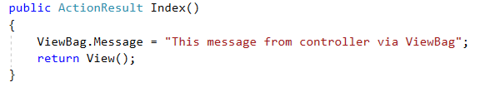

Step 2: Retrieve message in view Index.cshtml

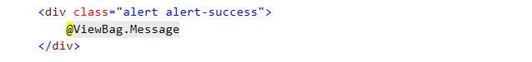

Step 3: Check result



### Solution 2: Use ViewData

Step 1: Update action Index, declare value and assign value to ViewData

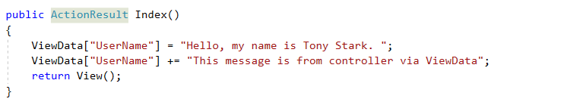

Step 2: Retrieve message in view Index.cshtml

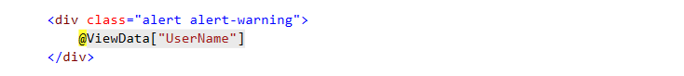

Step 3: Check result



### Solution 3: Use TempData

Step 1: Update action Index, declare value and assign value to TempData

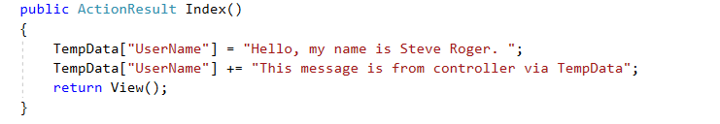

Step 2: Retrieve message in view Index.cshtml

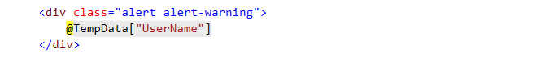

Step 3: Check result



### Solution 4: Use strongly type

Step 1: Create Student model

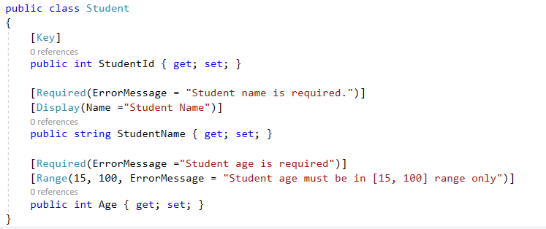

Step 2: Update action Index, declare value and assign value

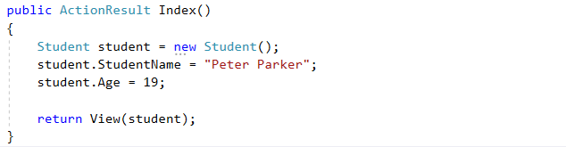

Step 3: Retrieve object in view Index.cshtml

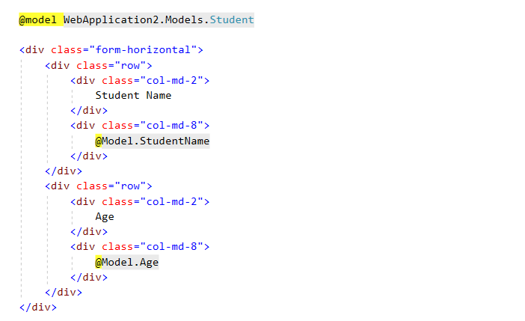

Step 3: Check result

